Christophe SAURY - 20239056
Midterm Report – Creative Algorithms
Exploring Creative Digital Works

For this midterm report, I wanted to choose three creative works that touch different areas of expertise and if possible that could be linked to my interests or to my major.
After looking through multiple artists portfolios, I decided on the three following works :
- « Embroidery » by Robert Hodgin
- « A Soft Murmur » by Gabriel Martin
- « We Feel Fine » by Johnathan Harris and Sep Kamvar
« Embroidery » is a visual work using 3D, a great color scheme and an interesting cutting method.
« A Soft Murmur » is a audio work that

The ever-evolving landscape of digital design has redefined the boundaries of creativity, transforming code into a canvas for artistic expression. In this report, we delve into the captivating world of creative digital works, focusing on three works from distinct fields : "Embroidery" by Robert Hodgin, "A Soft Murmur" by Gabriel Martin, and "We Feel Fine" by Jonathan Harris and Sep Kamvar. These works, hailing from the realms of generative art, interactive digital experiences, and data-driven visualization, represent a captivating cross-section of the possibilities inherent in creative coding.
Our aim is to do a deep dive on each of these works in the hope of gaining a deeper understanding on how to use code in more diverse ways to create more creative works. From the evocative visual landscapes of "Embroidery" to the soothing interactive realm of "A Soft Murmur" and the exploration of collective emotions in "We Feel Fine," these works demonstrate a multitude of possibilities and dimensions that digital design can encompass.
I’ll start by presenting « Embroidery », it’s author and how itw as made, I’ll then move on to do a deep dive on « A Soft Murmur » before finishing with « We Feel Fine ».

I - "Embroidery" by Robert Hodgin :

"Embroidery" is a remarkable digital creation brought to life by Robert Hodgin. Hodgin is a co-creator of the Cinder C++ framework. Having a degree in Sculpture and being a talented coder, his work showcases a unique blend of technical expertise and artistic sensibility.
he has been a prominent figure in the field of generative art and creative coding. His portfolio is available at : https://roberthodgin.com/

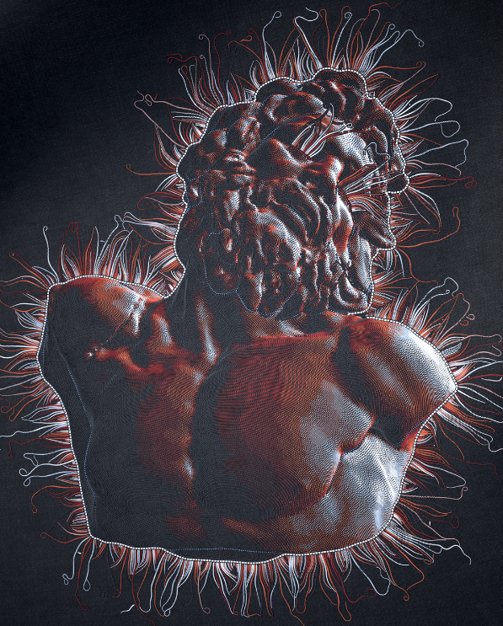
The captivating work of "Embroidery" represents a fascinating exploration of generative art and visual aesthetics. This mesmerizing piece was crafted using the Processing programming language, an open-source graphical library and integrated development environment. Processing provides artists and designers with a versatile platform for creating interactive, generative, and visual art.

The creation process for "Embroidery" involves the use of various algorithms and mathematical concepts. These algorithms dictate the behavior and movements of geometric forms and patterns on the screen. With precise control over colors, shapes, and motion, Robert Hodgin masterfully orchestrates a dance of elements that simulates the intricate and visually engaging characteristics of embroidered patterns.

Timeline

"Embroidery" was brought to life in 2009. Since its creation, Robert Hodgin has continued to refine and expand upon the work. As with many generative art pieces, the potential for evolution and refinement is ongoing, allowing the artist to explore new dimensions and possibilities over time.

Context and Significance

"Embroidery" holds a significant place in the world of generative art. It is a testament to the artistic potential of code and algorithms, and it highlights the artist's ability to mimic and extend traditional artistic techniques through digital means. The work adds to the growing body of generative art that seeks to explore the beauty and complexity of visual aesthetics created through mathematical precision.

Robert Hodgin's "Embroidery" is a shining example of how creative coding can blur the lines between technology and art, creating captivating and visually stimulating works that challenge our perception of what is possible in the digital realm. Its significance lies not only in its visual appeal but also in its role in inspiring others to experiment with generative art and explore the endless possibilities of creative coding.

